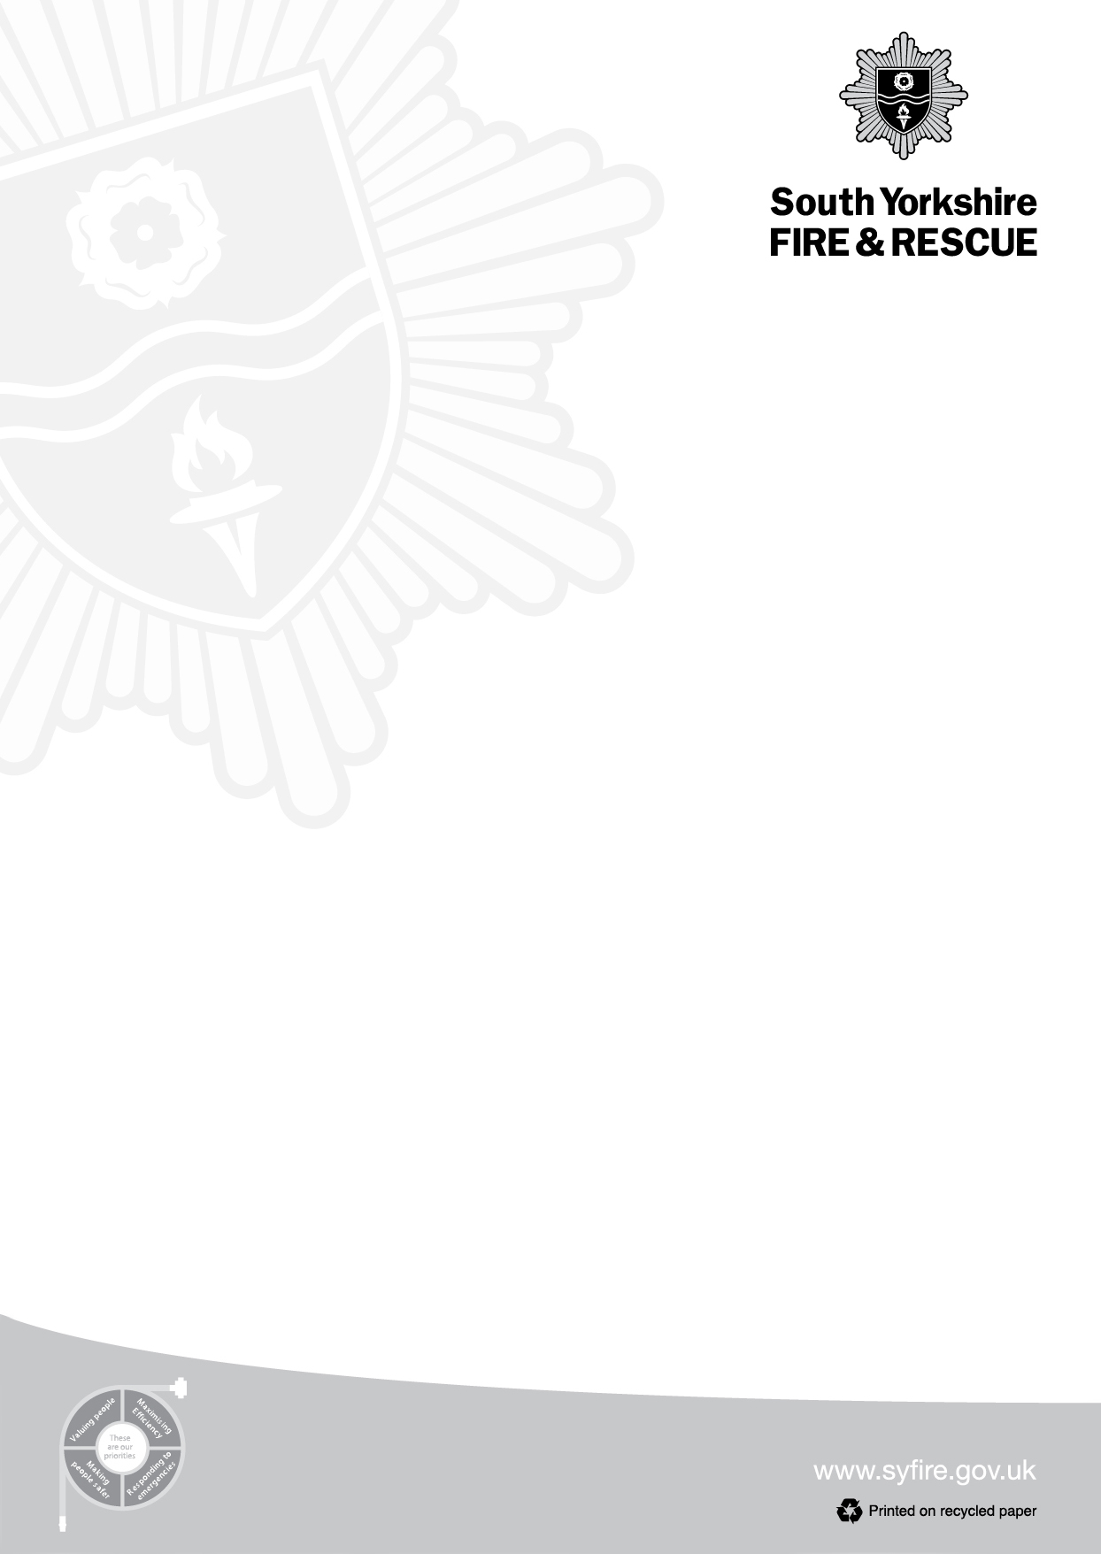
Chris Kirby
Chief Fire Officer & Chief Executive

Dear Parent/Carer,
Important Water Safety Notice
With several schools in our area located near bodies of water, we're reaching out to partner with you in protecting children's safety. Whether during winter when ice forms or in warmer months when swimming seems inviting, bodies of open water can pose serious risks to young people.
We kindly ask all parents/carers to have a crucial conversation with their children about water safety. Please discuss the following safety information with your family to help prevent accidents and ensure everyone stays safe around water throughout the year.
- Attempting to walk on frozen lakes, canals and reservoirs is dangerous and can be fatal.
- Whilst it may be tempting to walk on frozen water, the ice could be unstable and can easily break.
- The temperature of the water is so cold that it can take your breath away which can lead to panic and result in drowning.
- Even during the summer months, water is still cold beneath the surface so entering the water can result in cold water shock.
- The RNLI's "Float to Live" advice is to resist the instinct to swim hard to safety if you find yourself unexpectedly in the water. Instead, lean back, extend your arms and legs, and float. Tilt your head back with ears submerged, relax, and control your breathing. Use your hands to help you stay afloat and call for help or swim to safety if possible.
Please also see below link to our water safety video.

https://www.youtube.com/watch?v=R4oMsu1zl7o

Yours faithfully
Jessica Grayson
Station Manager
Community Safety, Prevention and Education

197 Eyre Street
Sheffield
S1 3FG
Website: www.syfire.gov.uk
Tel: 0114 2727202

